CHANGES HISTORY
PIC | Date | Remarks
BJM.MR | 2018.05.04 | Created
Ghaida | 2018.05.04

TOC
- Parameter System Simpi Status
- Parameter System User Status
- Parameter System Simpi Type
- Parameter System Invoice Type
- Parameter System Stat Protype
- Parameter System Order Type
- Parameter System Billing Type
- Parameter System Order Status
- Parameter System Ticket Type
- Parameter System Ticket Status

Diagram ENTITY RELATIONSHIP

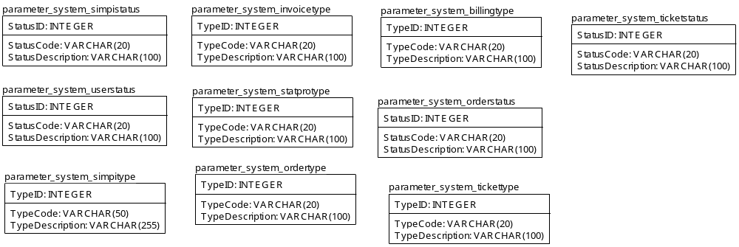

TABLE RELATIONSHIP
No | Table 1 | Table 2 | Type (1:1; 1:N; M:N) | Description

Name |  | parameter_system_simpistatus
Objective
No | Column |  | Type | Rule  (PK, FK, Key, NN, Unik, Index) | Description
1. | StatusID |  | Integer | NN
2. | StatusCode |  | Varchar(20) | Null
3. | StatusDescription |  | Varchar(100) | Null

SAMPLE DATA
No | Column | Sample 1 | Sample 2 | Sample 3 | Sample 4
1. | StatusID | 1 | 2 | 3 | 4
2. | StatusCode | UNITHOLDER | INVESTOR | FUND MANAGER | REFERRAL
3. | StatusDescription | INVESTOR MUTUAL FUND | INDIVIDUAL INVESTOR | FUND MANAGER | SALES REFERRAL

Name |  | parameter_system_userstatus
Objective
No | Column |  | Type | Rule  (PK, FK, Key, NN, Unik, Index) | Description
1. | StatusID |  | Integer | NN
2. | StatusCode |  | Varchar(20) | Null
3. | StatusDescription |  | Varchar(100) | Null

SAMPLE DATA
No | Column | Sample 1 | Sample 2 | Sample 3 | Sample 4
1. | StatusID | 1 | 2 | 3
2. | StatusCode | ACTIVE | SUSPEND | CLOSE
3. | StatusDescription

Name |  | parameter_system_simpitype
Objective
No | Column |  | Type | Rule  (PK, FK, Key, NN, Unik, Index) | Description
1. | TypeID |  | Integer | NN
2. | TypeCode |  | Varchar(50) | NN
3. | TypeDescription |  | Varchar(255) | Null

SAMPLE DATA
No | Column | Sample 1 | Sample 2 | Sample 3 | Sample 4
1. | TypeID | 1 | 2 | 3 | 4
2. | TypeCode | UNITHOLDER | INVESTOR | FUND MANAGER | REFERRAL
3. | TypeDescription | INVESTOR MUTUAL FUND | INDIVIDUAL INVESTOR | FUND MANAGER | SALES REFERRAL

Name |  | parameter_system_invoicetype
Objective
No | Column |  | Type | Rule  (PK, FK, Key, NN, Unik, Index) | Description
1. | TypeID |  | Integer | NN
2. | TypeCode |  | Varchar(20) | Null
3. | TypeDescription |  | Varchar(100) | Null

SAMPLE DATA
No | Column | Sample 1 | Sample 2 | Sample 3 | Sample 4
1. | TypeID | 1 | 2 | 3
2. | TypeCode | CREDIT ORDER | CREDIT BILLING | OTHERS SERVICES
3. | TypeDescription | CREDIT ORDER | CREDIT BILLING | OTHERS SERVICES

Name |  | parameter_system_statprotype
Objective
No | Column |  | Type | Rule  (PK, FK, Key, NN, Unik, Index) | Description
1. | TypeID |  | Integer | NN
2. | TypeCode |  | Varchar(20) | Null
3. | TypeDescription |  | Varchar(100) | Null

SAMPLE DATA
No | Column | Sample 1 | Sample 2 | Sample 3 | Sample 4
1. | TypeID | 1 | 2
2. | TypeCode | HOLDING BASED | TRANSACTION BASED
3. | TypeDescription

Name |  | parameter_system_ordertype
Objective
No | Column |  | Type | Rule  (PK, FK, Key, NN, Unik, Index) | Description
1. | TypeID |  | Integer | NN
2. | TypeCode |  | Varchar(20) | Null
3. | TypeDescription |  | Varchar(100) | Null

SAMPLE DATA
No | Column | Sample 1 | Sample 2 | Sample 3 | Sample 4
1. | TypeID | 1 | 2 | 3 | 4
2. | TypeCode | NEW ACCOUNT | CREDIT ADD | CREDIT REMOVE | APPLICATION ADD
3. | TypeDescription | NEW ACCOUNT | CREDIT ADD | CREDIT REMOVE | APPLICATION ADD

Name |  | parameter_system_billingtype
Objective
No | Column |  | Type | Rule  (PK, FK, Key, NN, Unik, Index) | Description
1. | TypeID |  | Integer | NN
2. | TypeCode |  | Varchar(20) | Null
3. | TypeDescription |  | Varchar(100) | Null

SAMPLE DATA
No | Column | Sample 1 | Sample 2 | Sample 3 | Sample 4
1. | TypeID | 1 | 2 | 3
2. | TypeCode | MONTHLY | QUARTERLY | YEARLY
3. | TypeDescription | Monthly Based | Quarterly Based | Yearly Based

Name |  | parameter_system_orderstatus
Objective
No | Column |  | Type | Rule  (PK, FK, Key, NN, Unik, Index) | Description
1. | StatusID |  | Integer | NN
2. | StatusCode |  | Varchar(20) | Null
3. | StatusDescription |  | Varchar(100) | Null

SAMPLE DATA
No | Column | Sample 1 | Sample 2 | Sample 3 | Sample 4
1. | StatusID | 1 | 2 | 3 | 4
2. | StatusCode | SUBMIT | INVOICE | PAID | FREE TRIAL
3. | StatusDescription | SUBMIT | INVOICE | PAID | FREE TRIAL

Name |  | parameter_system_tickettype
Objective
No | Column |  | Type | Rule  (PK, FK, Key, NN, Unik, Index) | Description
1. | TypeID |  | Integer | NN
2. | TypeCode |  | Varchar(20) | Null
3. | TypeDescription |  | Varchar(100) | Null

SAMPLE DATA
No | Column | Sample 1 | Sample 2 | Sample 3 | Sample 4
1. | TypeID | 1 | 2
2. | TypeCode | SIMPI SUPPORT | SIMPI SALES
3. | TypeDescription | SIMPI SUPPORT | SIMPI SALES

Name |  | parameter_system_ticketstatus
Objective
No | Column |  | Type | Rule  (PK, FK, Key, NN, Unik, Index) | Description
1. | StatusID |  | Integer | NN
2. | StatusCode |  | Varchar(20) | Null
3. | StatusDescription |  | Varchar(100) | Null

SAMPLE DATA
No | Column | Sample 1 | Sample 2 | Sample 3 | Sample 4
1. | StatusID | 1 | 2 | 3 | 4
2. | StatusCode | SUBMIT | READ | FOLLOWUP | RESOLVED
3. | StatusDescription | SUBMIT | READ | FOLLOWUP | RESOLVED

